Early Bird

**PC / Android**

**Target Age: 8+**

**E – Everyone**

# Game Summary:

Race against time to be the first to get the biggest, juiciest worm amongst the flock! Don’t get distracted by that crusty old bread, instead collect some berries to increase your speed to so you’ll be the first to reach the worm!

As the runt of the flock, Minny has never been able to get to the worm before someone else pecks it up. But no longer! Help Minny run faster than the wind to get to the worm before anyone else, and reach the top of the pecking order!

## Unique Selling Points:

* Race against time to be the first to get to the worm
* Multiple levels
* Avoid obstacles that will slow you down
* Battle monstrous worms
* Collect food items as you go
* Work your way up the pecking order

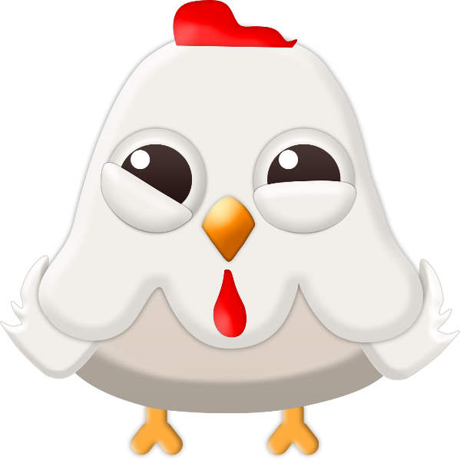

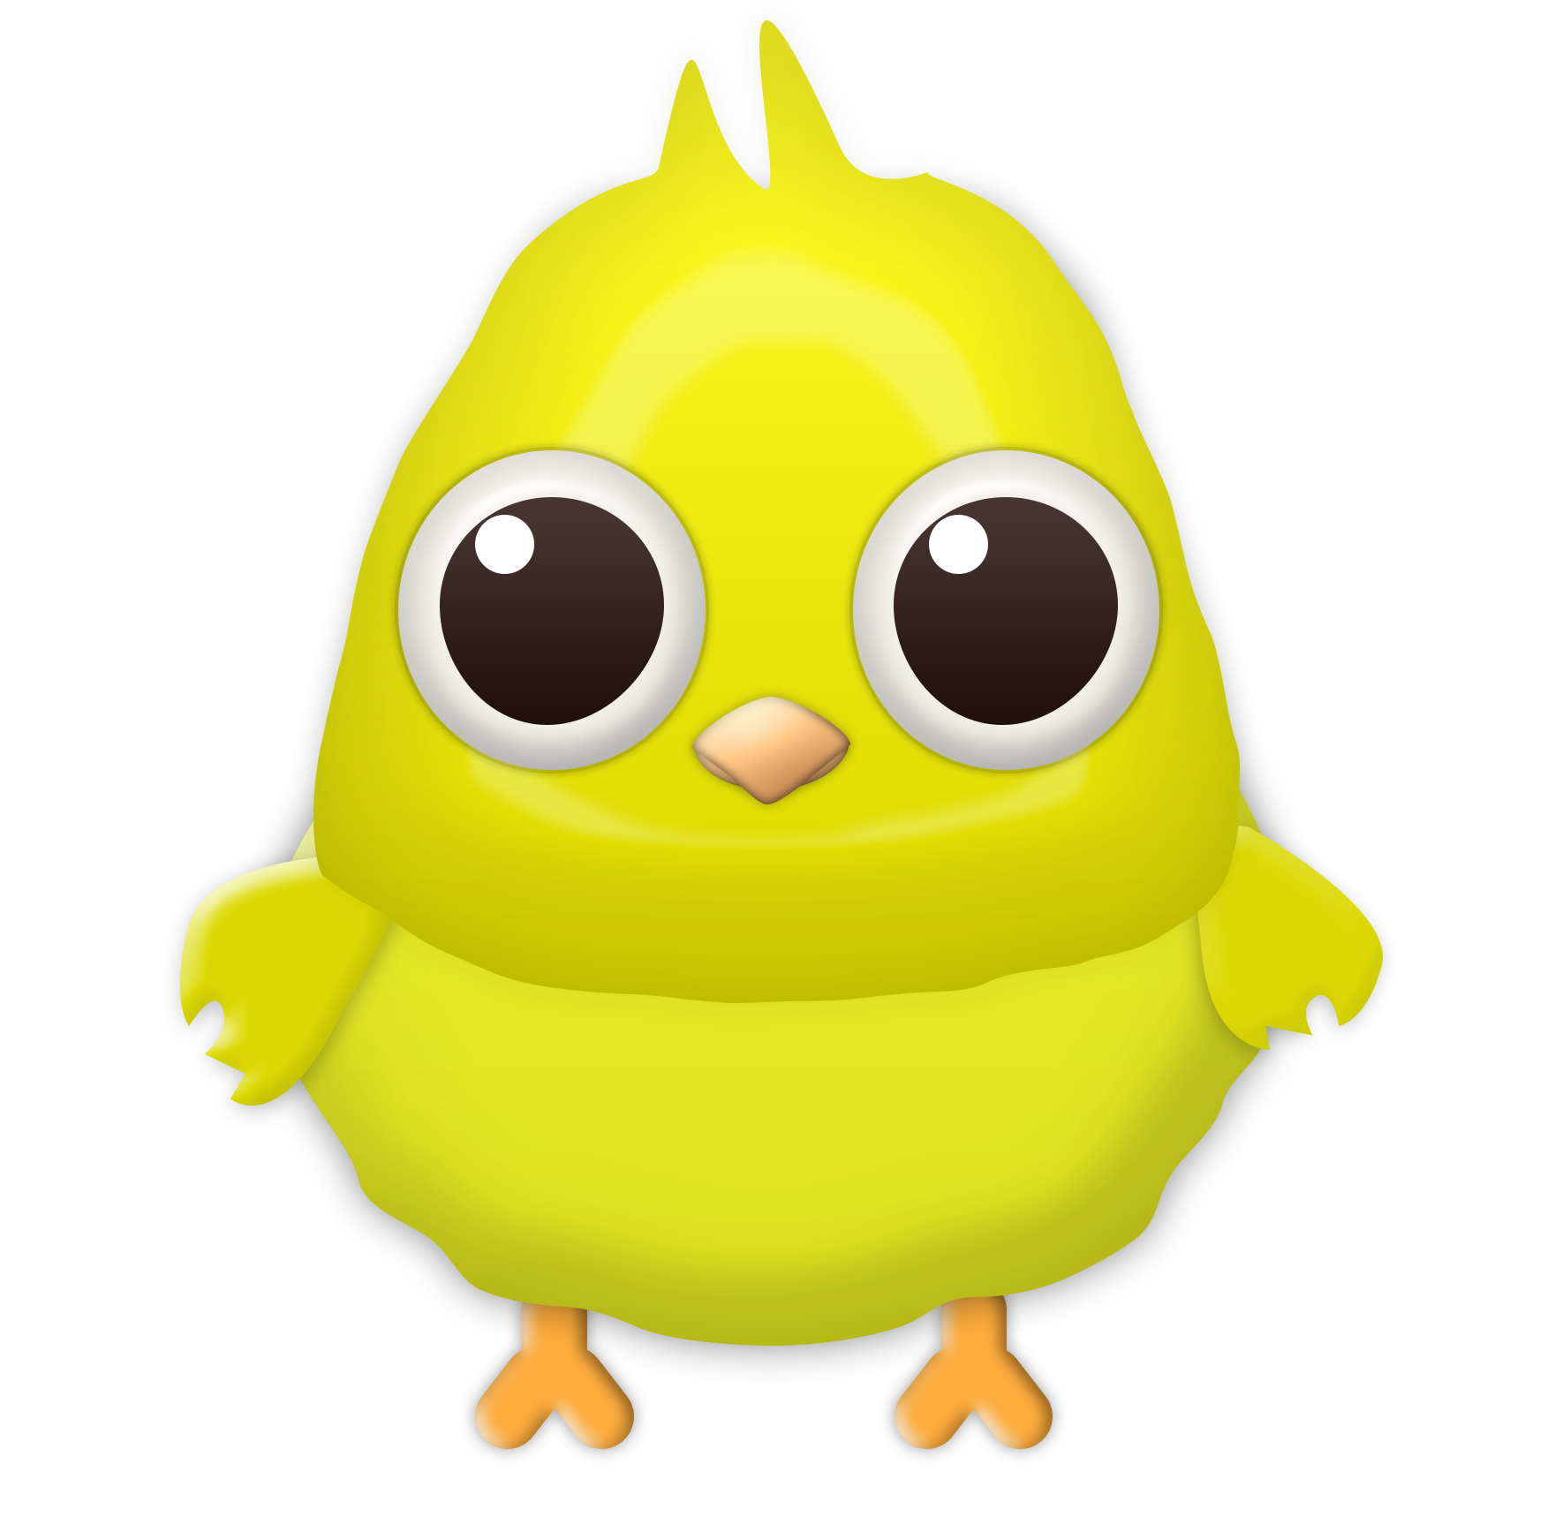

Early Bird:

**For PC / Android**

**Age: 8+**

**Rating: E - Everyone**

**Ship Date: TBD**

## Game Outline:

Minny, the runt of the flock, is never the one to get the big juicy worm. But no longer! Help Minny run faster than the wind to get to the worm before anyone else, and reach the top of the pecking order!

Race against time to be the first to get the biggest, juiciest worm amongst the flock! Avoid distractions, like delicious toast, and collect berries to increase your speed to so you’ll be the first to reach the worm!

## Character Description:

Whilst perhaps not the brightest or fastest hen, Minny has big dreams; to be the first to get to the worm! But as the runt of the flock, Minny is always beaten to the punch. So never knowing when the next big meal will come, Minny will never leave any food uneaten. Anything that comes across her path she’ll eat.

One day, after finding some delicious red berries, Minny has noticed that the berries seem to give her some extra energy. After some (extensive) thinking, Minny came up with an idea. She’ll use these berries to give her enough energy and speed to beat the other birds to the worm!

As the game progresses with each level, Minny will discover increasingly bigger worms that she will eventually need to battle with to drag home to show off to her peers.

## Gameplay:

* Minny runs constantly, without the need for user input
* Colliding with ‘delicous toast’ slows Minny down for a set period of time
* Berries speeds Minny up for a set period of time
* Tap spacebar (or the screen for Android) to jump
  + Future Feature: Boss fights with monstrous worms
  + Future Feature: Attack by double tapping (spacebar for PC / screen for Android)

## Game World Description:

Early Bird is set in a country side farm environment, surrounded by grassy fields. The player will run across these fields to reach the worm. If Minny falls off of a platform, she will land safely on the luscious grass, and go back to the last checkpoint.

At the end of the level, marked by an exit sign, Minny will find a worm. For the first couple of levels this worm will be relatively small, but as the game progresses the worms will become bigger and bigger. Eventually leading to separate boss fight scenes.

## Game Experience:

### Start Screen:

When the game is run the user will first see the start menu, and the cheerful theme music will start to play. The player can choose to either start the game by clicking on ‘Play’, or exit the game by clicking on ‘QUIT’. The option to quit will remain throughout the game, being on the top right corner of the screen during levels. On the bottom right of the start menu is short instructions on how to play the game.

Once the player chooses to click on Play, the scene changes to a description of the game’s storyline. The player can choose next, which takes the player to the first level of the game.

The whole game has a cheerful, carefree feel to it, matching the personality of our protagonist; Minny .The sky is blue with fluffy white clouds, and the grass is green, the perfect countryside farm. The feel of the game was made keeping in mind the targeted age range of 8+, keeping it friendly and adorable.

## Gameplay Mechanics:

### Timers:

On the top left corner of the screen, the player will be able to see a timer. This is the timer for the level; this is the one the player will race against to reach the worm (and end the level). One it reaches 0, the current level will restart. If the end of the level is reached before the timer runs out then the player will proceed to the next level.

### Hazards:

Minny needs a little help figuring out when to jump in order to avoid running into objects or falling off of platforms. Make sure you let her know when the right moment to jump appears.

### Collectables:

Minny is constantly hungry, and will gobble up any food that comes across her path.

Running without a meal will only get Minny so far. Collect some supercharged berries along the way for a light super charged snack.

*This is a permanent effect, and can only be changed when another berry / piece of bread is eaten.

Make sure to avoid any toast that comes across Minny’s way. Whilst delicious, bread will only slow Minny down.

*This is a permanent effect, and can only be changed when another piece of bread/ berry is eaten.

Sometimes Minny will come across a mysterious bug. Minny is fascinated by these bugs and will stop to look at them until they fly away (player will be immobilised during this time). Avoid these if you can to keep from losing precious time!

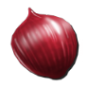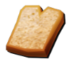

### Enemies:

With each completed level and worm collected, Minny will prove herself and move up the pecking order. This will give her access to bigger, more awe inspiring boss worms!

Fight and defeat these bosses to parade in front of your flock, and move to the very top of the pecking order! Each boss worm will have its own unique fighting style. Within these boss fighting levels, Minny will have a set time (separate from the time to get to the worm) to fight and defeat the worm with attacks unique to her;

* Frantic flapping (spacebar / tap screen once)
* Confused screech (double tap screen / spacebar) – once available after 5 successful hits with Frantic Flapping.

#### **Enemy Concept Art:**

